Worksheet#1: BEGINNING PROGRAMMING
Crossword Puzzle
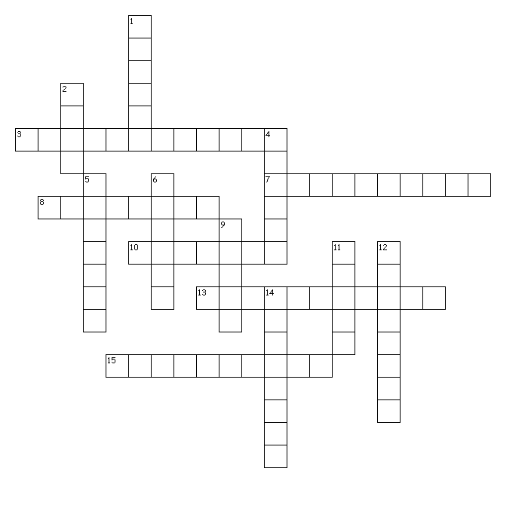

Clues

Across
3. pane for trying out Java code.
7. <, >, ==, !=, <=, >= are ______________ operators.
8. _______________ point numbers are numbers with a decimal point in them.
10. tells the compiler to change the type of the item to the specified type.
13. pane for creating programs.
15. are individual characters that can be made with one key stroke on your keyboard.

Down
1. a free integrated development environment for doing Java programming.
2. +, -, *, /, and % are ________________ operators.
4. an object that has a sequence of characters.
5. true or false values that are represented by the type __________________.
6. numbers made up of only 2 digits.
9. pane for listing of open files.
11. uses 8 bits.
12. are written to run on computers.
14. numbers without fractional parts.

Worksheet#1: BEGINNING PROGRAMMING
Crossword Puzzle
ANSWER KEY
Across
3. Interactions
7. Relational
8. Floating
10. Casting
13. Definitions
15. Characters

Down
1. DrJava
2. Math
4. String
5. Boolean
6. Binary
9. Files
11. Bytes
12. Programs
14. Integers

